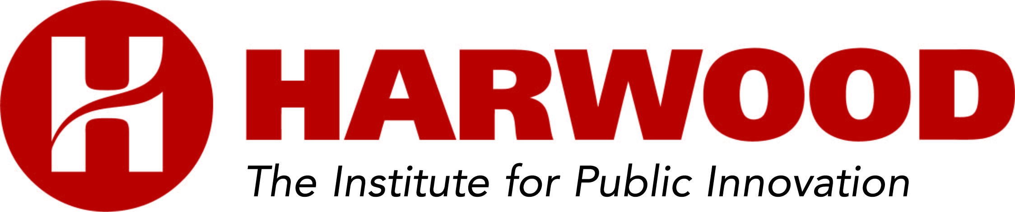

THE HARWOOD PUBLIC INNOVATORS LAB

AGENDA

Day 1 –UNDERSTANDING MY COMMUNITY AND BEING TURNED OUTWARD
8:00 - 8:30 | Registration and Continental Breakfast
8:30 – 9:10 | Opening Session  - Welcome and Introduction of Harwood Coaches  - Agenda and Learning Goals
9:10 –10:30 | Understanding My Community: Part 1  - Step 1: Focus on Public Knowledge  - Step 2: Ask the Right Questions
10:30 -10:45 | Break
10:45 - 11:15 | How Change Happens
11:15 – 12:30 | Understanding My Community: Part 2  - Step 3: Apply New Knowledge to Making Sound Decisions
12:30–1:30 | Lunch
1:30 – 2:45 | Understanding My Community: Part 3  - Step 4: Understand what I am learning – and how to listen  - Step 5: Share what I am learning to build community ownership and allies
2:45 - 3:00 | Break
3:00 – 4:15 | Turning Outward  - Step 1: Make the personal choice to Turn Outward
4:15 – 5:00 | Wrap Up

Day 2 – BEING TURNED OUTWARD AND CREATING CONDITIONS FOR CHANGE AND SUSTAINABILITY
8:00 – 8:30 | Continental Breakfast
8:30 – 8:45 | Opening Day Two
8:45 – 10:15 | Being Turned Outward  - Step 2: Apply Turning Outward to My Daily Choices
10:15 – 10:35 | Break
10:35 – 12:00 | Being Turned Outward  - Step 3: Embed Turning Outward Across Key Functions
12:00 – 1:00 | Lunch
1:00 – 1:30 | Voice from the Field
1:30 – 3:00 | Creating Conditions for Change and Sustainability  - Step 1: Know the stage of my community and its implications for effective action
3:00 – 3:15 | Break
3:15 – 4:30 | Creating Conditions for Change and Sustainability  - Step 2: Identify the right conditions to accelerate and support change
4:30 – 5:00 | Wrap Up  - Top Public Innovator Collaboration winners from each learning group will share their presentation with their peers  - Winning team gets bragging rights … and a prize!

Day 3 – DECIDING ON THE RIGHT PATH AND MAKING AN AGREEMENT WITH MYSELF
8:00 – 8:30 | Continental Breakfast
8:30 – 9:00 | Welcome Day 3
10:00 – 11:30 | The Public Innovators Toolkit  - Review the toolkit we have provided to help you apply what you’ve learned back home
10:30 – 10:45 | Break
10:45 – 11:30 | The Public Innovators Toolkit (cont’d)
10:00 – 11:30 | Deciding on the Right Path  - Step 1: Identify my sphere of influence  - Step 2: Choose the best path to win  - Step 3: Create an action plan
11:30 – 12:00 | Making an Agreement with Myself  - Step 1: Create a personal covenant  - Step 2: Identify what rejuvenates you
12:00 – 12:30 | - Celebration and Closing

